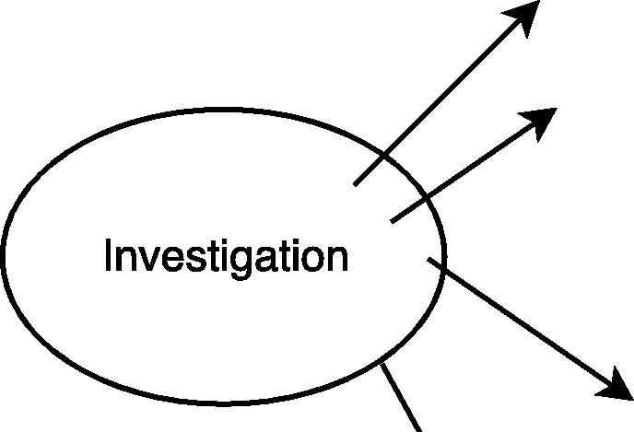**What is this stage?**

Having satisfied oneself that there is nothing that is evident to abandon the idea, one gets into the details of the project.

**What is required in this stage:** Investigation is required to collect data

**What to study?:**

1. Dam project

Topography, geology, best location, social and environmental impact etc.

1. Road project traffic studies, topography, bridges to be built etc.

|  |
| --- |
| **Ethical responsibilities of**  **engineers during**  **the Investigation phase:**   * Has a thorough and unbiased study has been conducted? * Have all data and observations have been reported fully? * Is there any attempt to falsify or enhance the utility by hiding or falsely interpreting the data? * If it is a manufactured product, has the market survey been thorough and the utility and safety of the product fully covered in the study?   **Case study: Building a dam for irrigating hectares of land and for generating thousands of watts of power:**   * Is the investigation exhaustive and complete? * Does the report of the investigation fully covered the details of the land submerged and people displaced, and estimate the damage to the ecosystem? * Has a mandatory environmental impact study been done thoroughly? * Has the interpretation of the study been done fairly without hiding facts? |